**Key Stage 3 Activity**

# Wildflower Guides Park & Garden

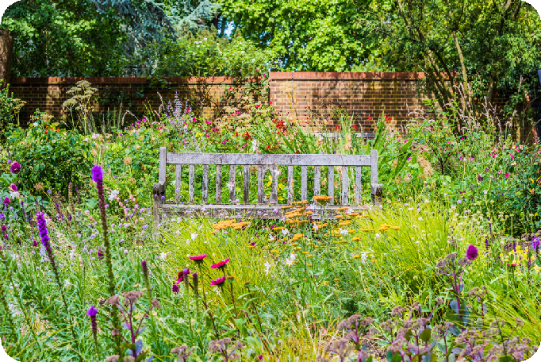

A park is an area of grass and plant land which is set aside for human enjoyment. Gardens are planted spaces, usually next to a home. Both of these areas are usually maintained by humans, which means biodiversity is often low, but many wildflowers and plants can still thrive in these places.

**Local spots:** Brynmill park, Rosehill quarry, Primrose park, Morriston park, Baglan Park, Gnoll Park

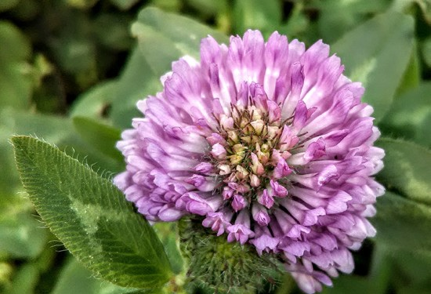

**Red Clover**

*Trifolium pratense*

Flower: June - September

**Habitat:** Common plant

found in most types of grassland. Roadsides and meadows.

**Appearance:** Recognisable 3 leaflet leaf cluster. Leaves are rounded and usually have a white banded marking.

Flowers grow in rounded head clusters.

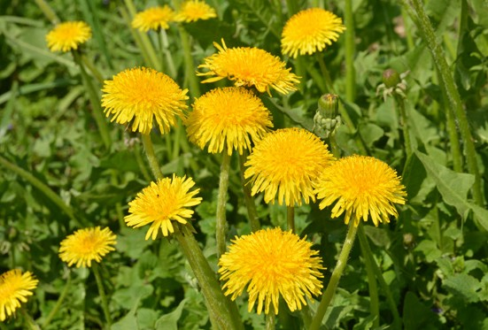

**Dandelion**

*Taraxacum spp*

Flower: March - October

**Habitat:** Widespread growing in

various grasslands. Roadsides, verges and meadows.

**Appearance:** Long ‘toothy’ leaves, flowerheads are a bright golden yellow of closely packed florets. When the flower fruits the seeds develop into fluffy umbrellas surrounding the dandelion.

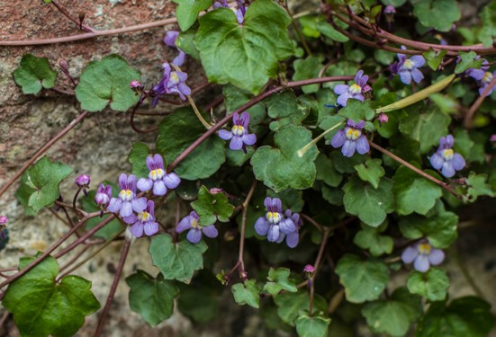

**Ivy Leaved Toadflax**

*Cymbalaria muralis*

Flower: April - September

**Habitat:** Walls, pavements

and rocky places.

**Appearance:** Trailing plant with reddish stems & small lobed leaves similar in shape to ivy leaves. Flowers are small, with two spurs and a lip, and are lilac in colour

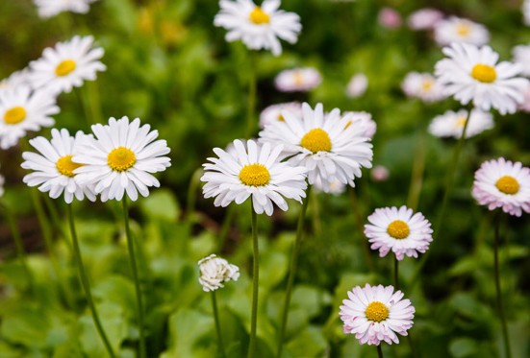

**Daisy**

*Bellis perennis*

Flower: All year round

**Habitat:** Common

everywhere and often found in garden lawns.

**Appearance:** Leaves are long & rounded in a rosette around the stem. The flowers are a composite of tiny individual flowers. The yellow floret in the centre is surrounded by white ‘petals’.

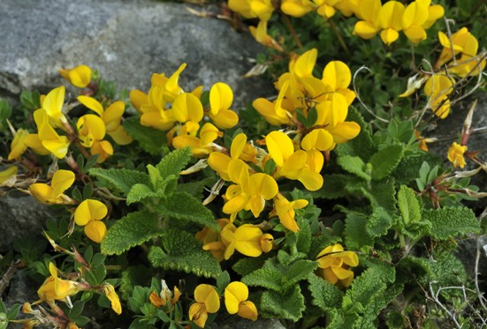

**Bird’s Foot Trefoil**

*Lotus corniculatus*

Flower: June – September

**Habitat:** Widespread in

grassland. Roadside verges, parks and wasteland.

**Appearance:** A member of the pea family, it has 3 main leaflets. The flowers are bright yellow and slipper shaped. Often has a seed

pod that looks like a bird claw.

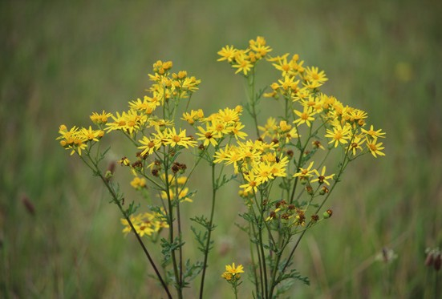

**Ragwort**

*Senecio jacobaea*

Flower: June - October

**Habitat:** Pastures, wasteland

and gardens.

**Appearance:** A tall, yellow plant, a favourite of cinnabar moth caterpillars. The flowers are flat-topped with fine, toothed leaves. It is a weed in grazing lands due to it being poisonous to cattle.

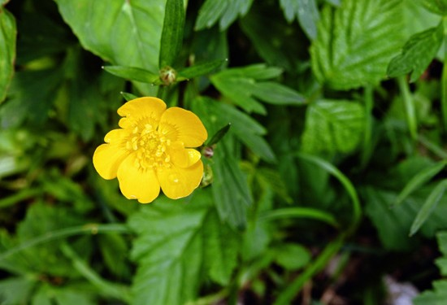

**Creeping Buttercup**

*Ranunculus repens*

Flower: March - August

**Habitat:** Often found in

damp grasslands, meadows, pastures and roadsides.

**Appearance:** Leaves and stems are slightly hairy. Leaves are divided in 3 toothed leaflets. Glossy yellow flowers. Low laying and spreads through runners.

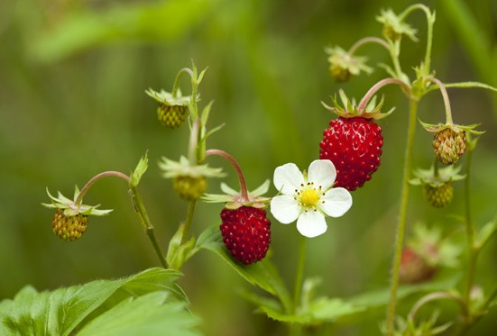

**Wild Strawberry**

*Fragaria vesca*

Flower: April - July

**Habitat:** Woodlands,

scrublands and clearings.

**Appearance:** White flowers, with 5 petals that slightly overlap. Toothed leaves with hairs underneath.

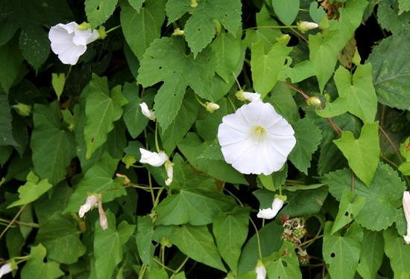

**Bindweed**

*Convolvulus arvensis*

Flower: June - September

**Habitat:** Hedges,

roadsides and farmland.

**Appearance:** Trumpet shaped flowers that are either white or pink. Leaves are larger and heart shaped.

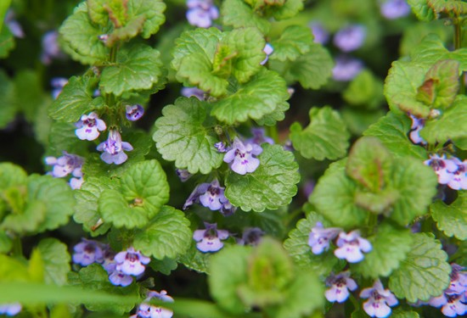

**Ground Ivy**

*Glechoma hederacea*

Flower: March - May

**Habitat:** Grassland,

woodlands and wasteland.

**Appearance:** Small plant with rounded, hairy leaves. The flowers are violet & funnel shaped, with spots on the lower lip.

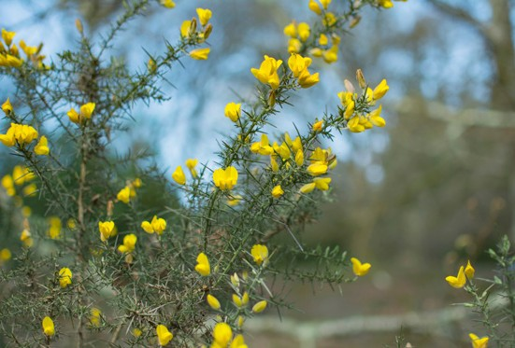

**Gorse**

*Ulex europaeus*

Flower: All year round

**Habitat:** Widespread, from

heaths to grasslands to coastal areas.

**Appearance:** Common shrub with bright yellow flowers and large needle-like leaves. Can often be a large growing shrub.

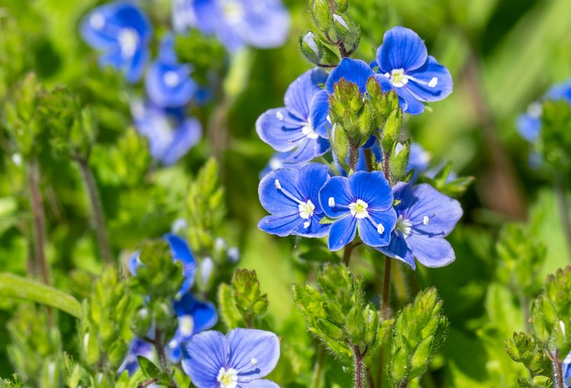

**Germander Speedwell**

*Veronica chamaedrys*

Flower: March - July

**Habitat:** Woodlands,

hedges and grasslands.

**Appearance:** Four petalled, bright blue flowers with a white centre. Heart shaped, hairy leaves with toothed edges.

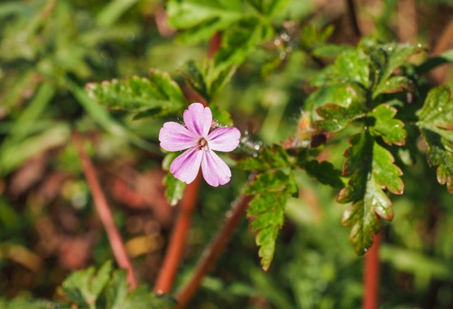

**Herb Robert**

*Gerannium robertianum*

Flower: May - September

**Habitat:** Common

everywhere and often found in garden lawns.

**Appearance:** Pretty pink flower with five rounded end petals. Leaves are five-lobed and stem is reddish.

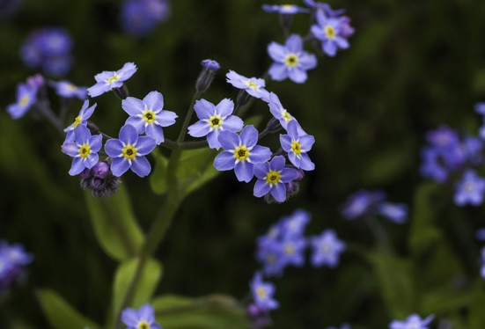

**Alpine forget-me-not**

*Myosotis sylvatica*

Flower: April - June

**Habitat:** Grasslands, gardens

and woodlands

**Appearance:** Stems are hairy and leaves are narrow & oval. The pretty flowers are bright blue with an orange centre.

**Plant Notes**

**Key Stage 3 Activity**

# Wildflower Guides Woodland

Swansea University Science for Schools Scheme

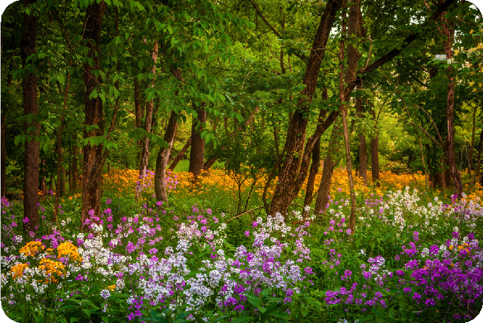

Woodlands are habitats where trees are the dominant plant. There are different types of woodland all around the world and all have different types of trees. Woodlands are important places for plant and animal life, providing food and shelter.

In Wales, our native woodlands are made up of deciduous trees – these are trees with flat, broad leaves that change colour and are shed each year.

**Local spots:** Clyne wood, Bishop’s wood, Penllergare valley wood, Margam forest, Afan Forest

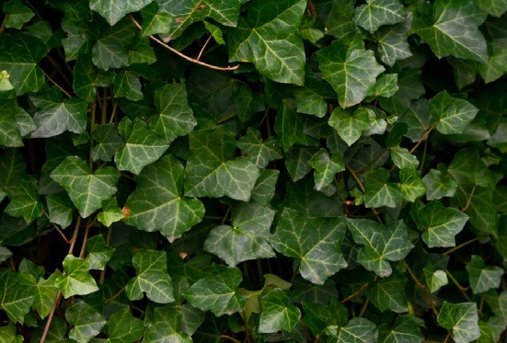

**Ivy**

*Hedera helix*

Flower: September - November

**Evergreen so can be seen**

**all year round.**

**Habitat:** Woodland, urban areas, parks and gardens.

**Appearance:** Dark green, glossy leaves with light green veins. Leaves are heart shaped.

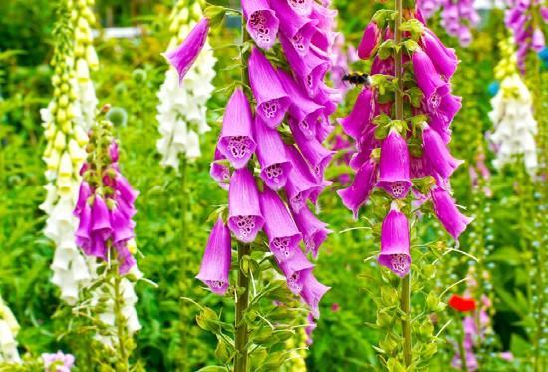

**Foxglove**

*Digitalis purpurea*

Flower: June - September

**Habitat:** Open woodland,

hedgerows and moorland.

**Appearance:** Tall plant with a spike of purple,

tube-shaped flowers. Leaves are oval and hairy.

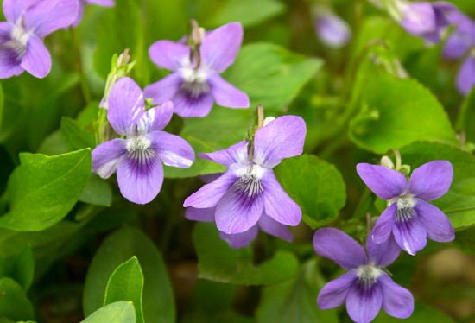

**Common Dog Violet**

*Viola riviniana*

Flower: April - June

**Habitat:** Woodlands,

grasslands, heathland, gardens.

**Appearance:** Small heart shaped leaves, flowers are blush purple and scentless, they resemble pansies.

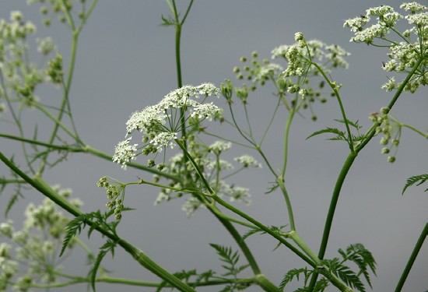

**Cow parsley**

*Anthriscus sylvestris*

Flower: April - June

**Habitat:** Woodland,

grassland, urban areas, gardens and roadsides.

**Appearance:** Feathery leaves, flowers are white and in an umbel - clusters of flowers with stalks which

come from a common centre.

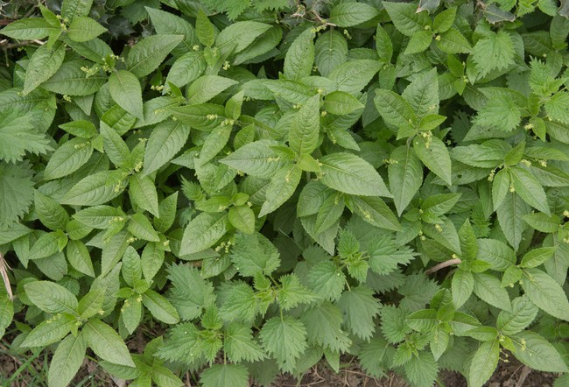

**Dog’s mercury**

*Mercurialis perennis*

Flower: Feb - April

**Habitat:** Ancient woodland,

broadleaf woodland, hedgerows and parks.

**Appearance:** Large, bright green, oval shaped leaves. They are toothed at edges and hairy. Flowers are small and green.

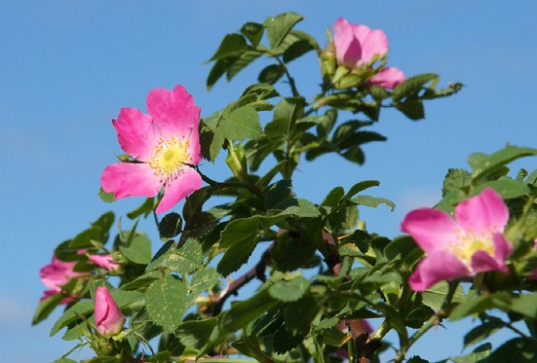

**Dog Rose**

*Rosa canina*

Flower: May - August

**Habitat:** Hedgerows,

woodland and grassland.

**Appearance:** A thorny climber, leaves occur on alternate sides of stem.

Divided into 2-3 pairs of tooth leaflets. Flower is large white or pink with 5 petals.

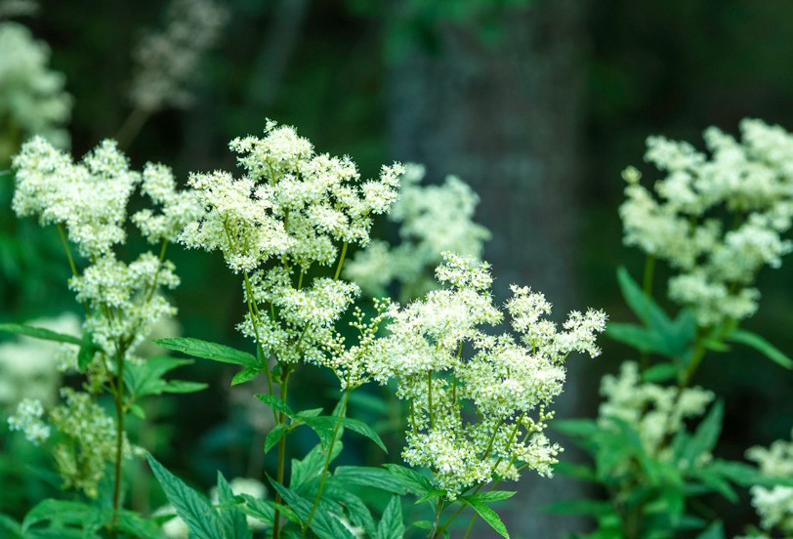

**Meadowsweet**

*Filipendula ulmaria*

Flower: June - September

**Habitat:** Woodland,

grassland, moorlands and wetlands.

**Appearance:** Creamy-white flowers arranged in messy clusters. Leaves are dark green & divided into paired leaflets with silver underside

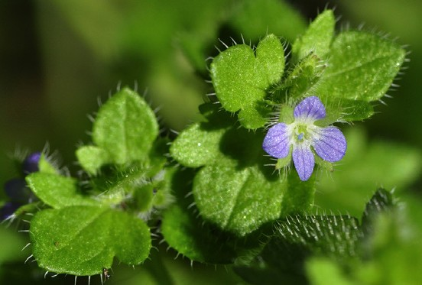

**Ivy-Leafed Speedwell**

*Veronica hederifolia*

Flower: March - August

**Habitat:** Woodland, gardens

and parks.

**Appearance:** Leaves are ivy-shaped, they are hairy & serrated. Flowers are small &

either pale blue or white.

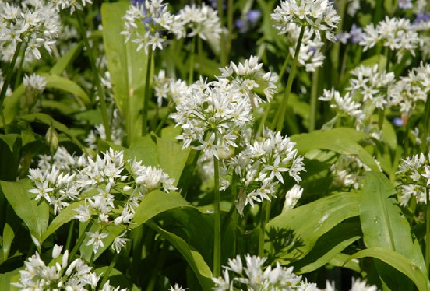

**Ramsoms**

*Allium ursinum*

Flower: April - June

**Habitat:** Woodland,

roadsides and parkland.

**Appearance:** Shade loving plant. Leaves are broad & pointed with a garlic smell and taste. White star shaped flowers that grow in clusters.

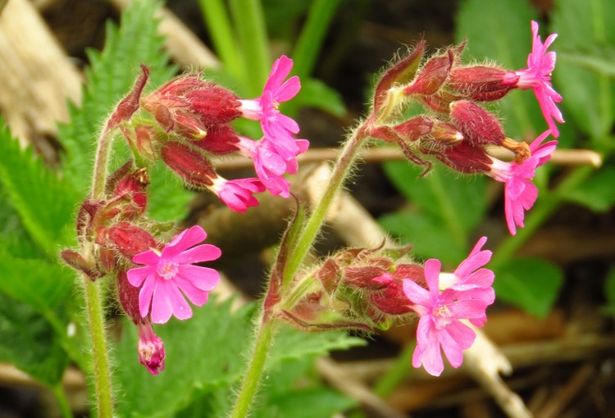

**Red Campion**

*Silene dioica*

Flower: May - September

**Habitat:** Woodland,

grassland and urban areas.

**Appearance:** A tall plant with hairy leaves that grow in opposite pairs. Pretty pink-red flowers with five petals, fused

at the base to form a tube surrounded by a purple-brown calyx (protective sheath).

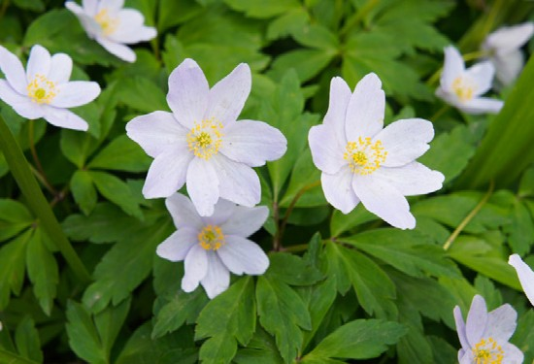

**Wood Anemone**

*Anemone nemorosa*

Flower: March - May

**Habitat:** Woodland, hedges

and banks.

**Appearance:** Star shaped, 6-petaled flowers which are either white or pink. Leaves are dark green with 3 lobes.

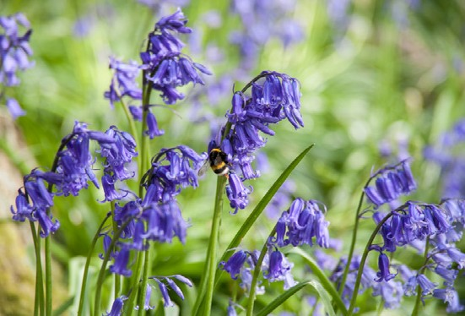

**Bluebell**

*Hyacinthoides non-scripta*

Flower: April – June

**Habitat:** Woodland, hedges,

banks and parks.

**Appearance:** Long, narrow leaves sprouting from base of stem. Flowers are bright blue and bell-shaped.

**Plant Notes & Doodles**

**Key Stage 3 Activity**

# Wildflower Guides Coastal

Swansea University Science for Schools Scheme

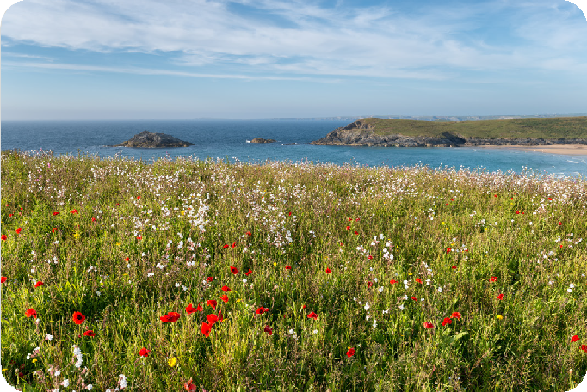

vulgareCoastal habitats are ones found close to the sea, this includes dunes, cliffs, grasslands, saltmarshes and wooded dunes. Despite being wet and windy, these habitats support a large range of life and are very important ecosystems. Our coastal habitats play a very important part in coastal defence, and in helping regulate our climate.

**Local spots:** Rhossili, Oxwich, Southgate, Kenfig

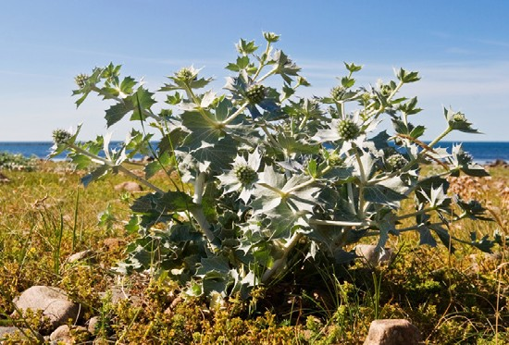

**Sea Holly**

*Eryngium maritimum*

Flower: All year round

**Evergreen so can be seen**

**all year round. Habitat:** Coastal.

**Appearance:** Has rounded blue flower heads, similar in look to thistle. Silvery blue leave with spiked edges.

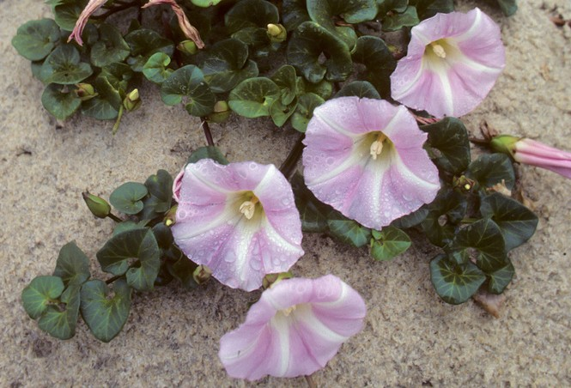

**Sea Bindweed**

*Calystegia soldanella*

Flower: June - August

**Habitat:** Coasts and dunes.

**Appearance:** Spreads along runners through sand. Leaves are rounded and heart shaped. The flowers are large rounded trumpets that are pink with 5 pale stripes.

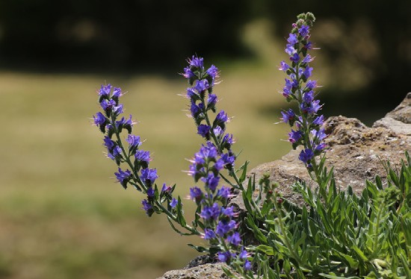

**Vipers Bugloss**

*Echium vulgare*

Flower: May - September

**Habitat:** Coasts, moorland

and heathland.

**Appearance:** Upright spikes of blue flowers in clusters. Stems are hairy and spotted, leaves are narrow and pointed.

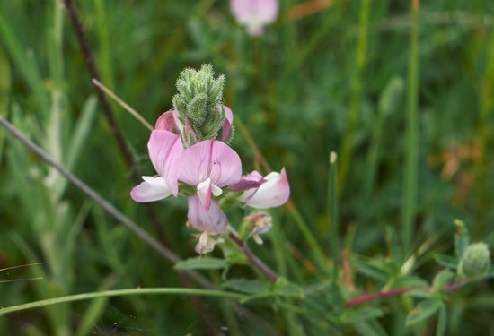

**Common Rest Harrow**

*Ononis repens*

Flower: July - September

**Habitat:** Coastland,

grassland, moorland and heathland.

**Appearance:** Leaves have a greasy feel & are divided

into 3 oval leaflets. Stems are hairy & flowers are pink,

pea-like clusters.

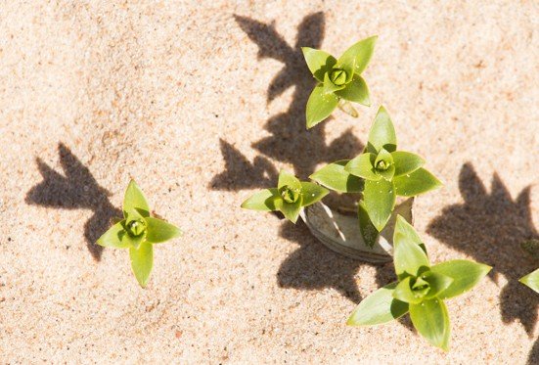

**Sea Sandwort**

*Honkenya peploides*

Flower: May - August

**Habitat:** Dunes.

**Appearance:** Small plant with dark, fleshy leaves. Stems grow close together forming tight clumps on dunes. Flowers are yellowish white.

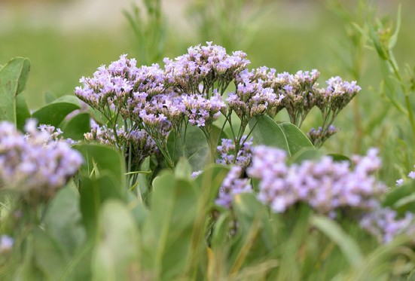

**Sea Lavender**

*Limonium vulgare*

Flower: July - October

**Habitat:** Coastal.

**Appearance:** Stiff, long stems with clusters of purplish flowers. Small oval leaves found at the bottom of the stem.

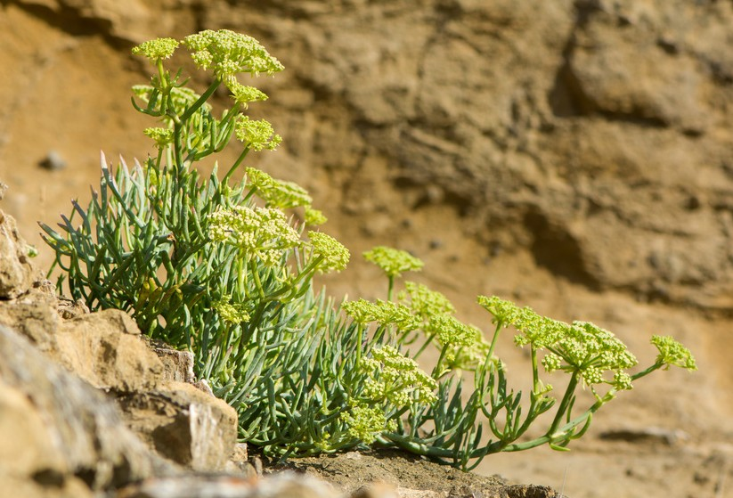

**Rock Samphire**

*Crithmum maritium*

Flower: July - October

**Habitat:** Cliffs and rocks

along coast.

**Appearance:** Grows in tight clumps. Flower heads are greenish yellow & grow in umbels. Leaves are thick & succulent.

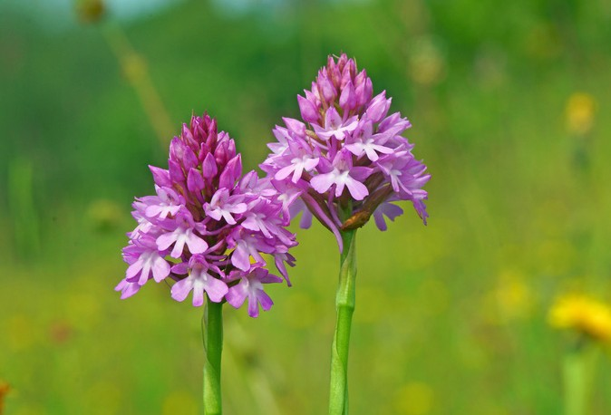

**Pyramidal Orchid**

*Anacamptis pyramidalis*

Flower: June - July

**Habitat:** Dunes and

grasslands.

**Appearance:** Bright pink flowers in a dense, pyramid- shaped cluster at the top of its stem. Has long, narrow and pointed leaves.

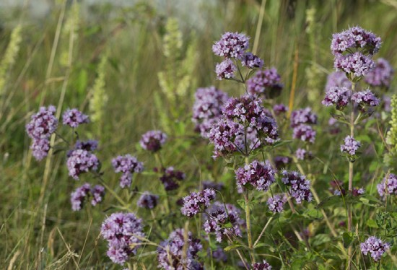

**Majoram**

*Origanum vulgare*

Flower: June - August

**Habitat:** Cliffs and rocks mostly

by the sea. Can be found growing from walls in parks and gardens in coastal areas.

**Appearance:** Inflorescences are tiny white-pink flowers, leaves are spade-shaped, being wider at the base. They are smooth with fine hairs and arranged opposite each other on the stem.

(S4) Funded by the European Social Fund and the Welsh Government.