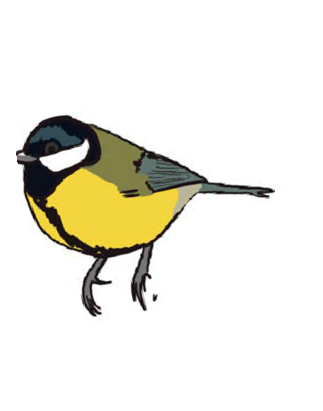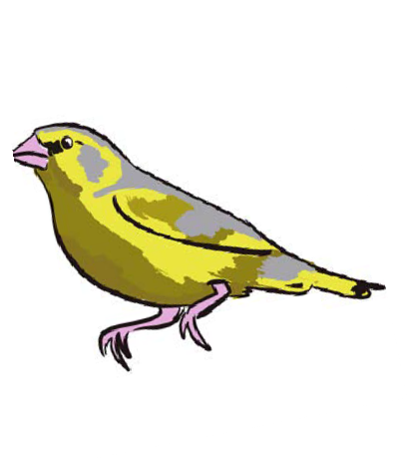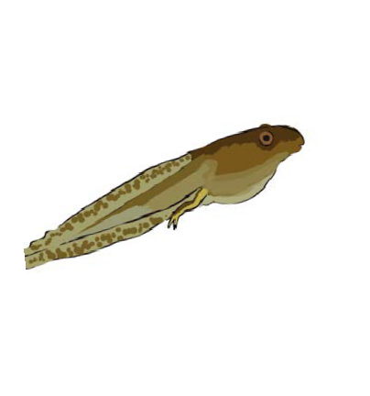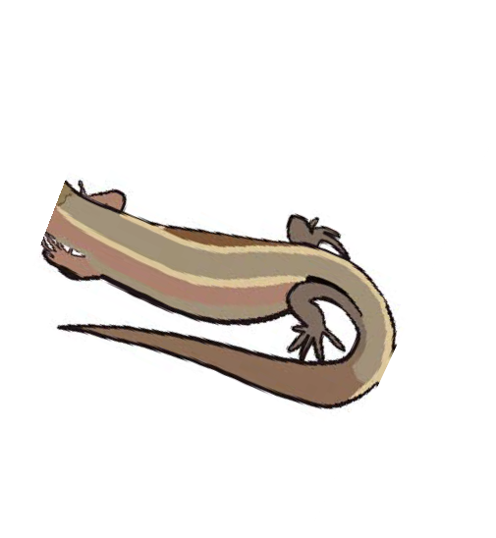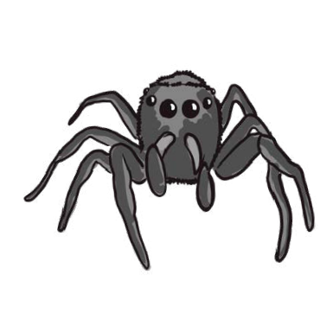

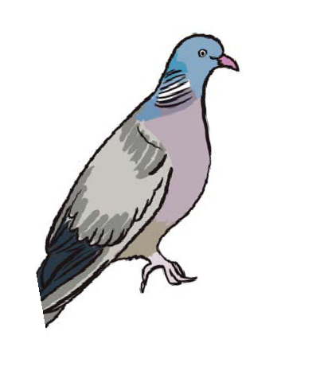
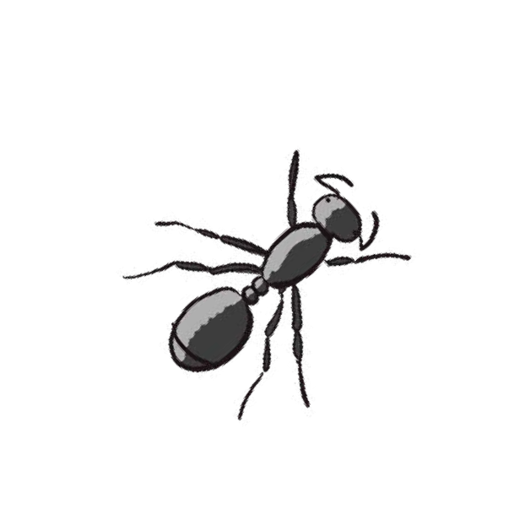
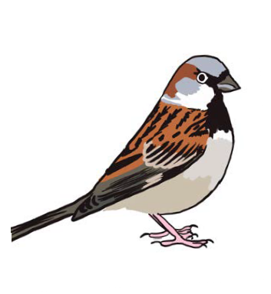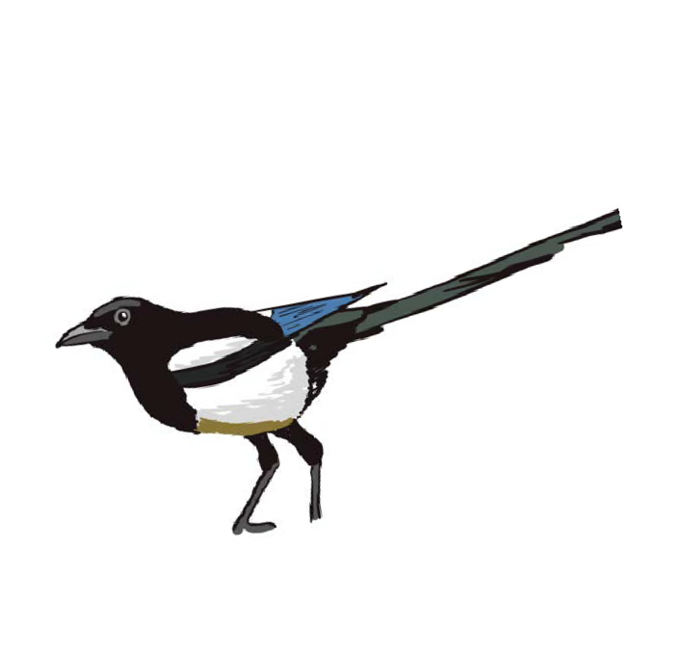What’s in your Garden?

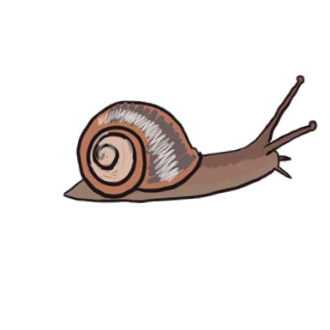
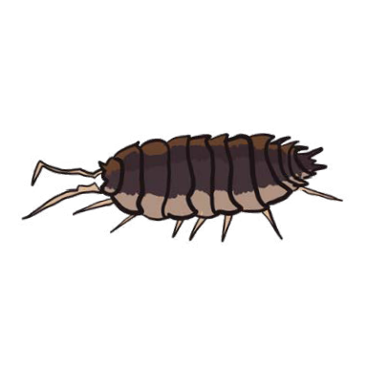
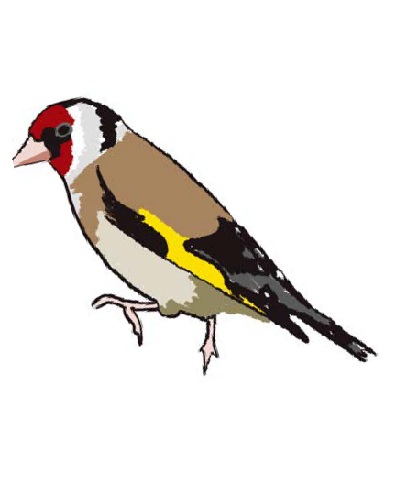
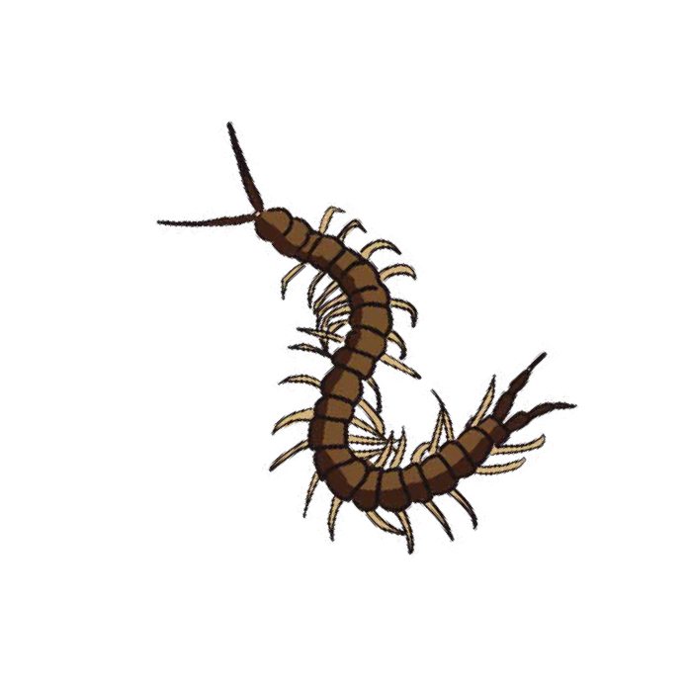
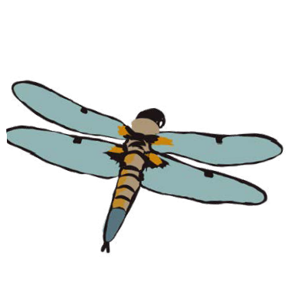
Your garden is bursting with all kinds of life. That’s true no matter the size or the amount of greenery. Use these guides to find and identify some of the wildlife you have at your fingertips.

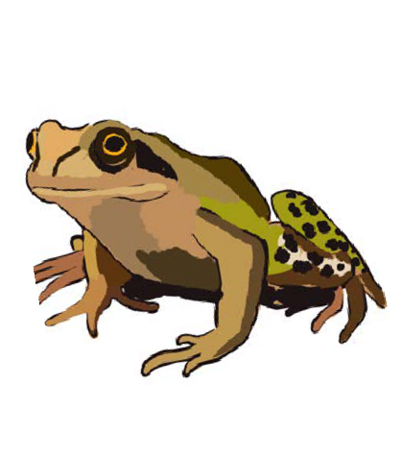
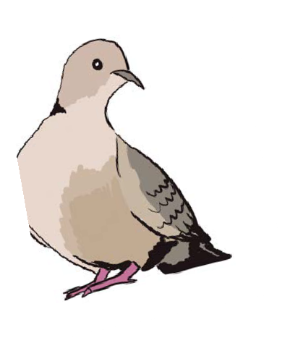
Swansea University Science for Schools Scheme

(S4) Funded by the European Social Fund and the Welsh Government.

Amazing Amphibians

If you’re lucky enough to have a pond in your (or your neighbour’s) garden you might see some of these lurking nearby. If not, try making your own mini-pond with the Wildlife Trust!

Swansea University Science for Schools Scheme

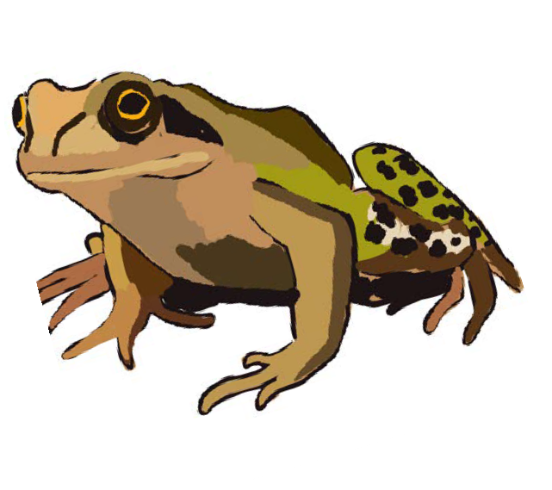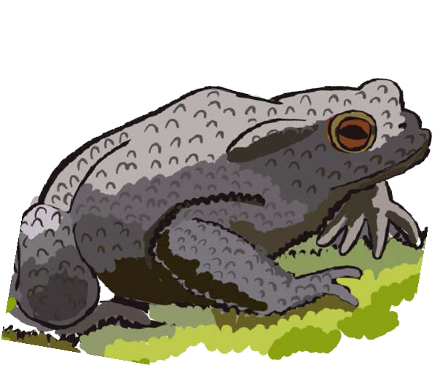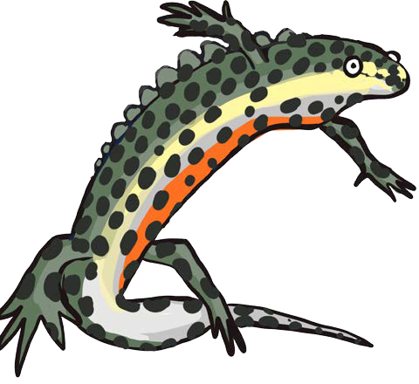Tadpole
Common Frog
All UK amphibians lay their eggs
in fresh water (think frog-spawn) around March. These eggs hatch into tadpoles in April. Tadpoles are adapted to life underwater, with features such as gills and tails! By June, tadpoles lose these features and gain lungs, legs and bones as they slowly metamorphose (change) into adults. The tadpoles of frogs
and toads are herbivores (plant- eaters) while newt tadpoles are carnivorous (meat-eaters) with diets that change to match the adults’ as they grow.
Common Toad
Of all the UK toads, you are most
likely to find a Common Toad in your garden. Look for dry, bumpy olive-brown skin and short legs, suitable for crawling rather than hopping. They lay their spawn
as long, uniform chains (like a string of beads) in spring. There is actually no real scientific difference between frogs and toads! Really, toads are just types of frogs that share certain features. UK toads all belong to the family Bufonidae, and frogs to Ranidae, which helps up separate them.
Smooth Newt
The Smooth Newt is the most
common species of newt spotted in gardens but don’t confuse one for a lizard! They have greyish skin, a bright orange belly and dark spots all over. During the spring, males have a smooth crest running down their back and tail. Newts will carefully wrap each of their eggs in the leaf of an underwater plant to hide them from predators - what thoughtful parents! They mostly live on
dry land, eating insects and they hibernate underground in the winter.
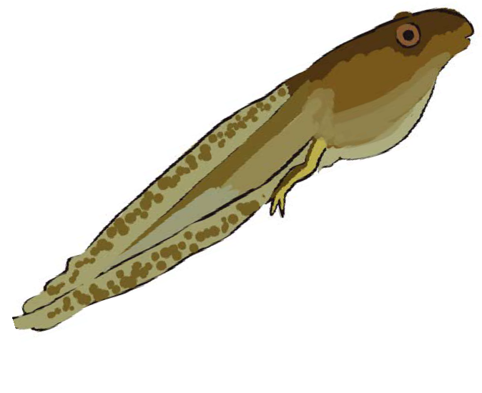

All UK amphibians lay their eggs in fresh water (think frog-spawn) around March. These eggs hatch into tadpoles in April. Tadpoles are adapted to life underwater, with features such as gills and tails! By June, tadpoles lose these features and gain lungs, legs and bones as they slowly metamorphose (change) into adults. The tadpoles of frogs
and toads are herbivores (plant- eaters) while newt tadpoles are carnivorous (meat-eaters) with diets that change to match the adults’ as they grow.

Brilliant Birds

Birds are easy to find. Just put out some bird seed (loose or in a feeder) and wait for them to flock to you. Get into the habit of putting out food and you’ll have regular visitors in no time!

Swansea University Science for Schools Scheme

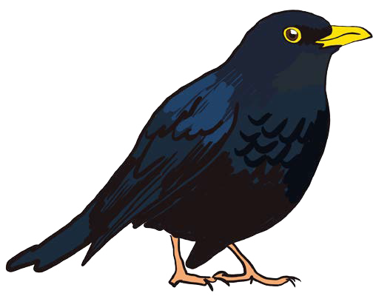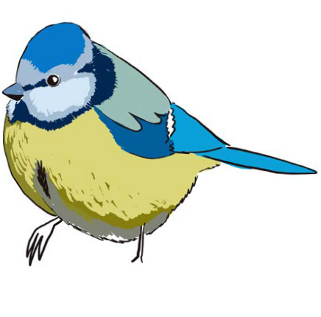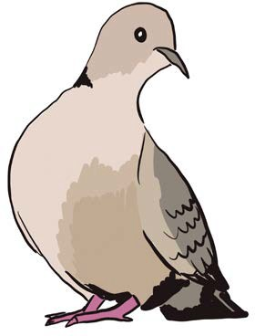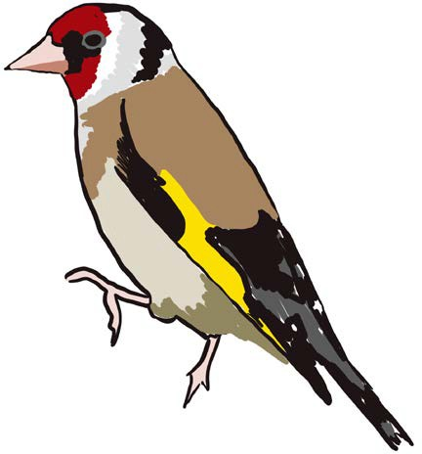
Blackbird
The males are very easy to
identify due to their jet black plumage (feathers) with bright
orange beaks and eye rings. The females are much browner, with a pale throat and speckles on the chest. They love mimicking the sounds around them, which means their singing tends to sound like car alarms! During the breeding season (April-August) they will fight each other for nest space, but it isn’t personal and they all happily roost together
in winter.
Blue Tit
Colourful, agile little birds - you
can easily spot their bright blue caps. In warmer months they love to eat insects from the tips of twigs and shoots. They also eat nuts and seeds but don’t like them as much, only eating
them when insects aren’t around (especially over winter). When raising their chicks, tits rely almost entirely on winter moth caterpillars. This is so important that they always make sure to lay their eggs so they will hatch when the caterpillars are most abundant!
Collared Dove
A pale, pinkish-brown bird with
a distinctive black collar around the back of the neck (hence its name!). They are closely related to the wood pigeon but they are a much rarer sight. Did you know there is no scientific difference between doves and pigeons?
Doves tend to be better liked but they’re all actually part of the same bird family! You can see collared doves pecking the ground around the bird table either by themselves or in pairs.
Goldfinch
Goldfinch You can spot a
goldfinch by it’s bright red face and yellow wing patches. Their favourite food is seeds from spiky plants, such as thistles, but how do they avoid getting hurt? Their beaks are long and thin, allowing
them to reach in between the spikes! Luckily for us, they are seen visiting bird tables and feeders in gardens more and more so keep a look out. Make sure to be looking in spring and summer as they migrate south as far as Spain for the winter.

Brilliant Birds Continued...

Birds are easy to find. Just put out some bird seed (loose or in a feeder) and wait for them to flock to you. Get into the habit of putting out food and you’ll have regular visitors in no time!

Swansea University Science for Schools Scheme

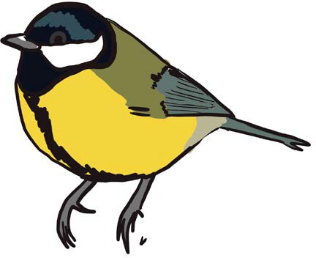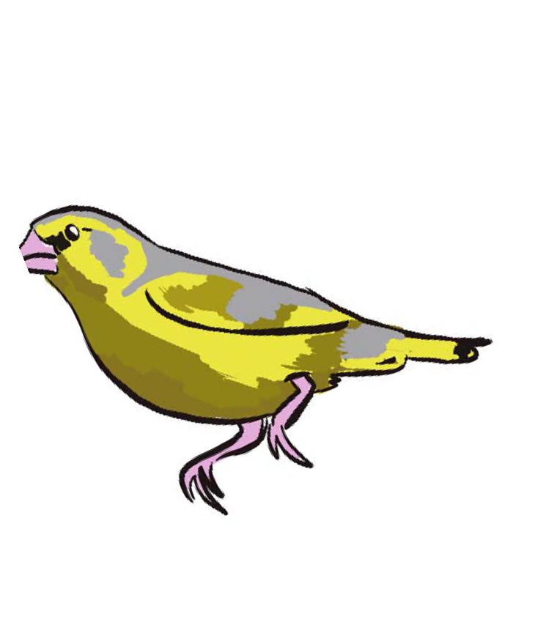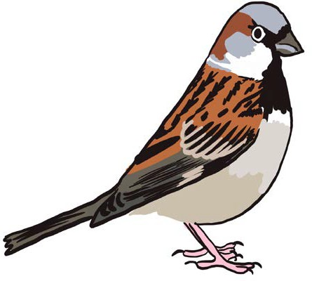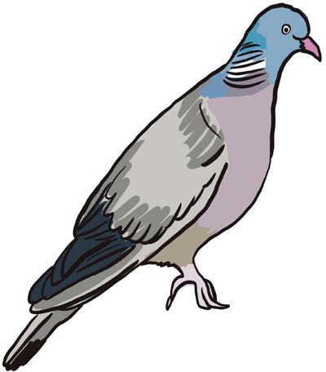
Great Tit
Very similar to the blue tit, but you
can tell them apart by the Great Tit’s larger size, black cap and line down the chest. They are also more likely to feed from the ground and are happier eating nuts and seeds in winter. Did you know, only 1 in 10 tits survive their first year outside the nest?
This sounds quite sad but it is very common among birds and is mostly due to natural causes. Without plenty of small birds for food, many predator species would starve.
Green Finch
The largest of the UK’s finches,
the greenfinch can be identified by it’s olive green and yellow plumage. The females also have a brownish tinge running down the head and back. Greenfinches love eating seeds but they are too heavy to eat straight from plants! They have to eat their seeds from the ground instead.
Sadly, their diet relies on weeds and the overuse of herbicides in today’s farming and gardening has reduced the amount of
food available.
House Sparrow
A small brown bird with black
speckles down the back and a short wide beak. The male also has an additional grey crown and black bib. House sparrows might be the bird with the closest relationship with humans, both
now and throughout history. They love to make nests in and around our buildings and are commonly seen in our parks and gardens. Sadly, Britain’s numbers have dropped an estimated 71% since the 1970’s.
Wood Pigeon
Similar to the feral pigeons you
can see in the town centre, but wood pigeon lack the shimmery chest of their inner city cousins.
They are also larger and lighter in colour with a white patch on the side of the neck. They are far too big to eat from bird tables or feeders so have to peck at the nuts and seeds that have fallen to the ground below. They are very clumsy and noisy flyers who produce a soft cooing call from tree tops.

Magnificent Mammals

Everyone loves seeing cute, fuzzy little critters but most only come out at night! Some can be a rare sight but, if you spot one, put some suitable food out and you’ll get return visitors in no time.

Swansea University Science for Schools Scheme

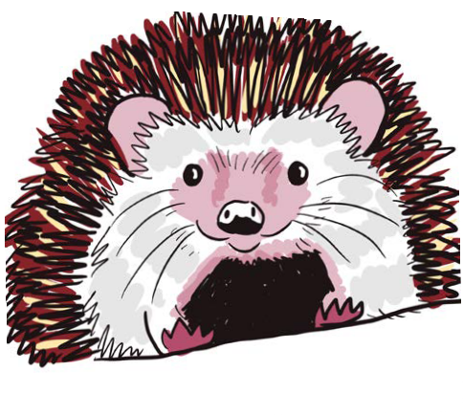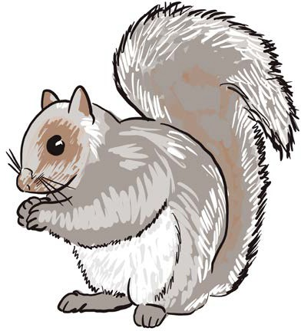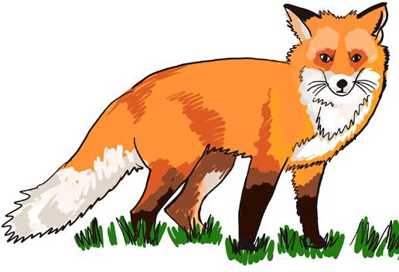Bat
European Hedgehog
If you search your garden at
night you might spot a hedgehog or two foraging (searching) for slugs and worms – but they will also enjoy a bowl of cat food! Did you know the UK’s hedgehog population has dropped more than 97% in the last 70 years?
They have lost a lot of their natural habitats. Hedgehogs are also in trouble because of the use of pesticides (chemicals sprayed on plants) to control pests like slugs and insects. If
the hedgehogs eat the poisoned pests, they also eat
the pesticides.
Grey Squirrel
Grey Squirrels are the mammal
you’re most likely to see in your garden, especially if you leave birdseed in easy-to-reach places.
They are identifiable by their grey fur and bushy tail that they use for balance in the tree tops. Grey Squirrels are actually an invasive species brought from America in
the 1800s that have out-competed the native Red Squirrel for food and habitat. They love nuts and seeds, burying a secret supply for winter which is often forgotten
about – allowing the seeds to grow.
Red Fox
Foxes are frequent night-time
visitors to our gardens – bin night especially! Redfur, pointy ears and bushy tails make the fox unmistakable, even from a distance. Most UK towns and cities have a large population, but their diet and behaviour can vary by location. For example, foxes in Bristol largely rely on scavenging human food waste but those in London mostly hunt wild mammals and birds. They are adapting to the people – Bristolians love foxes and often leave out food while Londoners consider them pests.
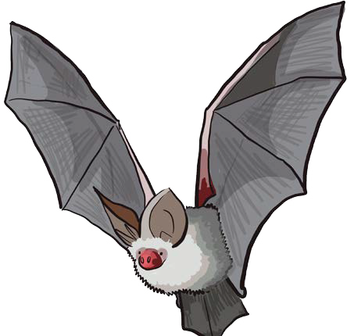

Bats are very common yet we often don’t see them because they come out at dusk, are very fast and small and tend to live in old buildings, ancient woods or rocky hideouts. There are 30 mammal species in the UK and
18 of those are bats! Telling them apart is very difficult without handling (please don’t do this,
it is illegal without a licence and bats a very fragile) but if you live in an urban or suburban area you are most likely to see a Pipestrelle Bat, while rural residents may also see Serotine and Long-Eared Bats (pictured).

Radical Reptiles

Reptiles are surprisingly common but extremely shy and tend to run away as soon as they sense people approaching. You may still spot them basking in the sun on a warm rock though.

Swansea University Science for Schools Scheme

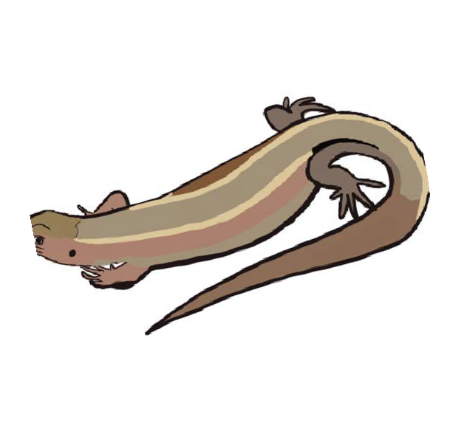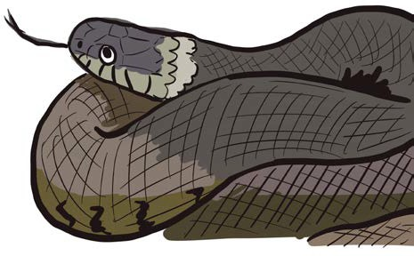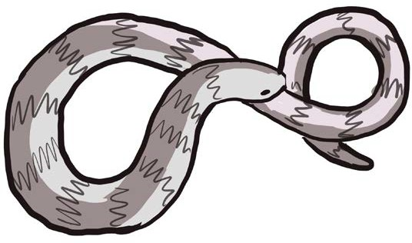Adder
Common Lizard
True to its name, the Common
Lizard is the UK’s most numerous and widespread reptile. They vary in colour from greys to browns to blacks. The males also have brightly coloured bellies with dark spots, while females have paler undersides.
Did you know their tails can grow up to double the length of their bodies? Not only that, but they can shed their tail at any time to distract potential predators (don’t worry it grows back). Unlike most reptiles, the females can give birth to live young.
Grass Snake
Grass snakes can be identified by
the yellow collar behind the head and their dark green or brown colouring. They are the UK’s largest snake, but don’t worry, they are completely harmless to humans. They are normally found in wetland or dry grassland but can also be found in gardens, especially if there’s a pond nearby – they can swim to hunt fish and amphibians, some of their favourite prey! Females lay their eggs in the warmth of rotting vegetation and incubate them (keep them warm) until they hatch in autumn.
Slow Worm
Despite its appearance, the slow
worm is not a snake (no it’s not a worm either!) but a legless lizard. You might be thinking that‘s the same thing but the slow worm has a few features that put is firmly in the ‘lizard’ group. They have smoother scales, can shed their tails and have eyelids (real snakes can’t blink!). They are also the most likely reptile for you to spot in your garden – especially if you have a compost heap, where they love to hunt slugs in summer and hibernate in winter.
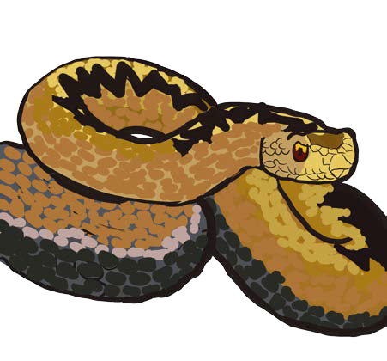
Adders are the UK’s only venomous snake and are most easily identified by their black zig-zag pattern and red eyes. They are very secretive and prefer to spend their time in heathland or moors, away from people. Their venom is used
to immobilize the lizards and small mammals they hunt and, although painful, is rarely fatal to humans. Adders would much rather slither away from people and only bite if they feel like they’re trapped and can’t get away. They are easiest to spot
basking on a warm rock in March, after their hibernation.

