**Key Stage 1 & 2 Activity**

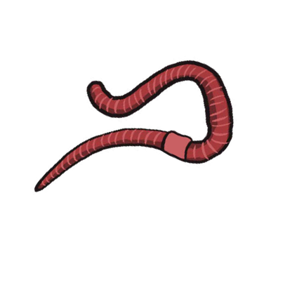

Earthworms

Dig just under the

surface to find these slimy fellows.

Alternatively pour some water on the ground and stomp around for a bit – trust us, this works!

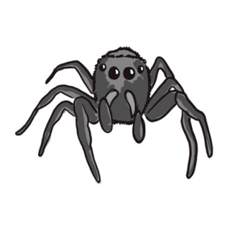

Spiders

8 legs, 8 eyes and

paralysing venom, spiders are great hunters. They wait patiently in their webs for prey, or hide amongst plants so they can stalk their dinner.

Creepy Crawlies

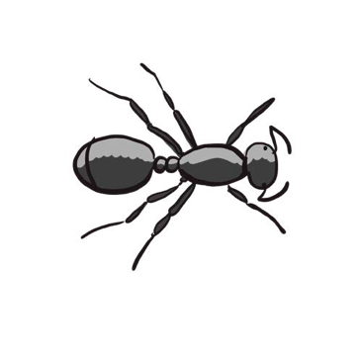

Ants

If you find one you’ll be

sure to find more! Ants live in big underground groups called colonies, coming to the surface to search for food.

These little guys are the easiest to find

– just look under any rock! They also happen to be the most diverse so keep your eyes peeled and try to find as many

as possible.

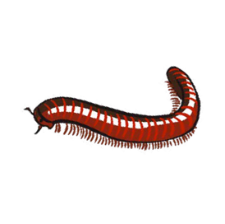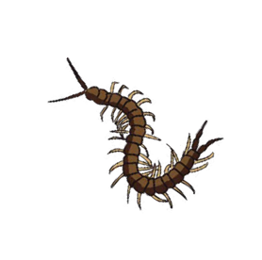

Centipedes & Millipedes

Centipedes are hunters,

using their antennae (the feelers on their heads) and back legs to find prey. Millipedes are gentle herbivores, and curl up when scared.

Your garden is bursting with all kinds of life. That’s true no matter the size or the amount of greenery. Use these guides to find and identify some of the wildlife you have at your fingertips.

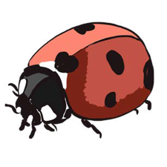

Beetles

Beetles make up 25%

of all life forms, so you can find them almost anywhere. Finding ladybirds is easy, but there’s plenty more out there!

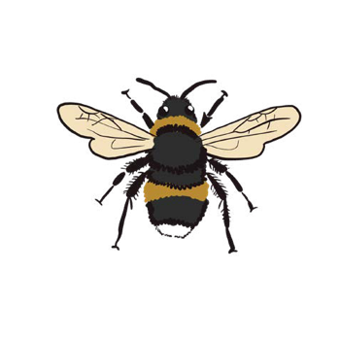

Bees

Honey bees work in

colonies while bumble bees live alone. The pattern of yellow and black stripes tells you the species. Look for them among the flowers!

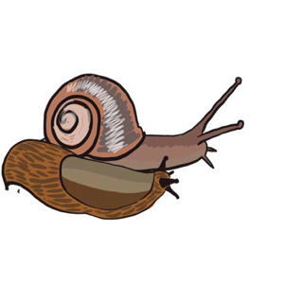

Slugs & Snails

These belong to a

group of animals called molluscs. They prefer damper parts of the garden and love to eat plants. They leave easy- to-follow trails as they go.

[Swansea University Science for Schools Scheme](http://www.s4science.co.uk/)

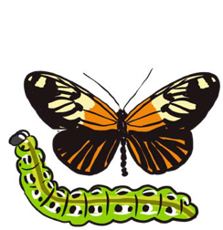

Butterflies & Caterpillars

Each butterfly pattern

represents a different species, with a matching caterpillar! Keep an

eye out for moths in the evening too.

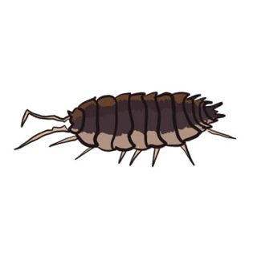

Woodlice

More closely related to

lobsters than insects, woodlice actually still have gills. They like to live in dark, damp

environments where they eat decaying plants.

Illustrations by Rebecca Ellis.