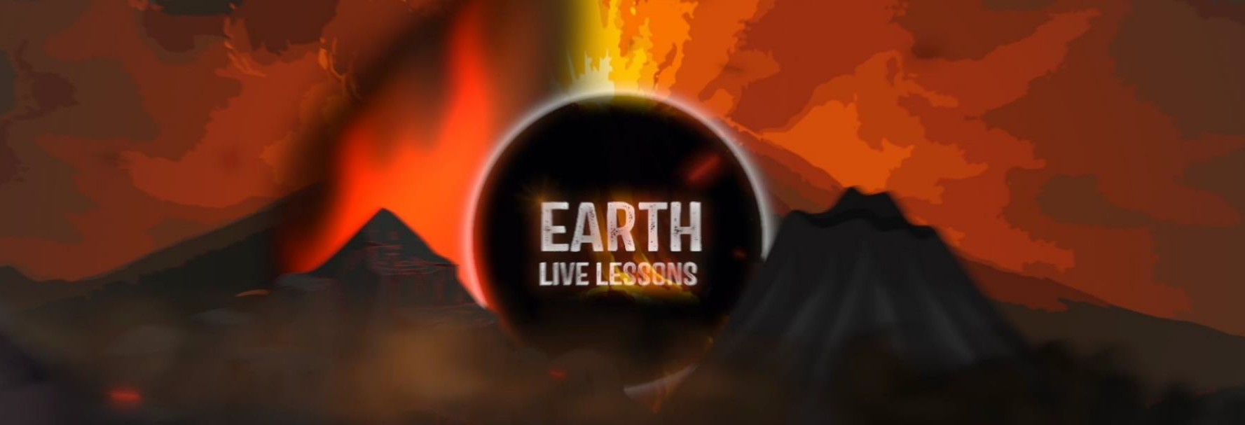
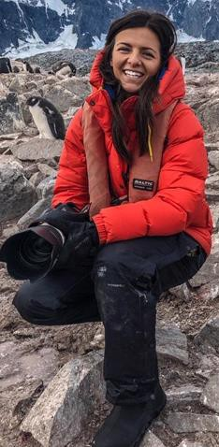
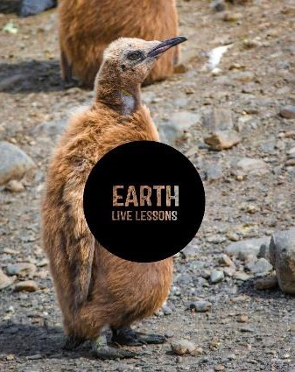
05/04/20
Video Link: https://www.youtube.com/ watch?v=0ZerSvkvpKQ
Dr Christian Dunn Wetlands
Key Stage 3&4

Name:

Hi! Thank you for watching our Earth Live Lessons. I hope you are enjoying them.
Now it is time to show what you know!
Good luck
Lizzie

Q1. What sort of wetland would you find in a coastal region? (circle the correct answer)
a) Mangrove b) Bogs c) Marshes
Q2. How much more CO² is stored in wetlands compared to forests?
Q3. List the 4 qualities that make
wetlands natures superheroes.
Q4. Why are ‘leaky’ dams, built by
beavers, good for flood protection?
Q5. What organisation is responsible for looking after wetlands in the UK?

In 1940 USA, beavers were dropped by parachutes to remote wetlands that needed flood management.
True / False

Q5. State 3 NEW things that you have learnt:
1.
2.
3.

Q6. What are the similarities and differences between the following:
- Fens and bogs
- marshes and swamps?
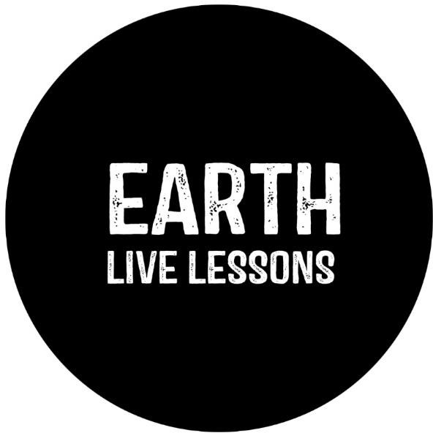

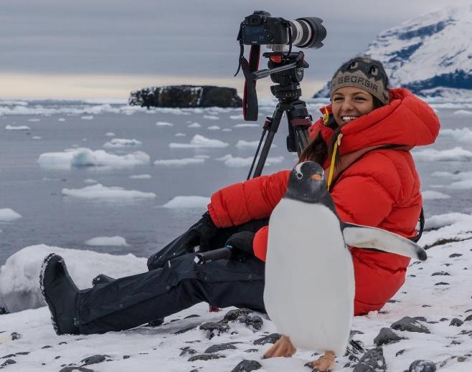
Follow me on:
Ask me a question!
Following today’s live lesson do you still have questions you want answered? If so, make sure you send them to Lizzie @LizzieRDaly on Twitter using #EarthLiveLesson #EarthLiveLessons and I’ll try to
answer them! Lizzie
@LizzieDalyWildlifeTV
@LizzieDalyWild
@LizzieDalyWildlife
@LizzieRDaly

