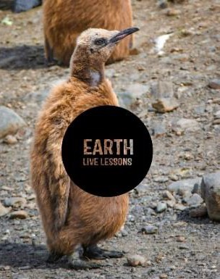
13/04/20
Video Link:
https://www.youtube.com
/watch?v=fi0LFk6Vp5g
Lyn Von Hagen
Human to Elephant coexistence Key Stage 3&4

Name:

Hi! Thank you for watching our Earth Live Lessons. I hope you are enjoying them.
Now it is time to show what you know! Good luck
Lizzie

Q1. At what age do male elephants leave the matriarchal (their mothers) herd?

Q2. When elephants forage away from the reserve into farming area this is known as? (circle the correct answer)
1) Crop Rotation 2) Crop Raiding 3) Crop Reduction

Elephants can communicate with sounds humans cannot hear.

True / False

Page 1
Q3. List the three species of elephant.
Q4. What is the biggest threat to elephants and why?
Q5. What is the gestation period for
an elephant?

Q6. How do farmers in Kenya use bee's to protect their crops?

Q5. State 3 NEW things that you have learnt:
1.
2.
3.

Follow me on:
@LizzieDalyWildlife @LizzieRDaly
Ask me a question!
Following today’s live lesson do you still have questions you want answered? If so, make sure you send them to Lizzie @LizzieRDaly on Twitter using #EarthLiveLesson #EarthLiveLessons and I’ll try to
answer them! Lizzie
@LizzieDalyWildlifeTV
@LizzieDalyWild
Page 2

