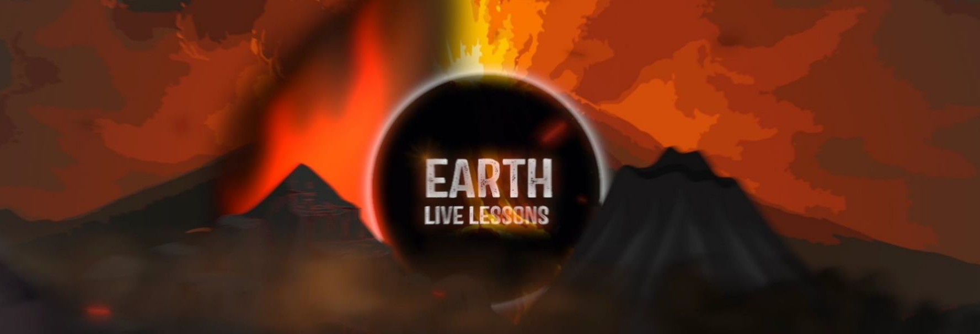
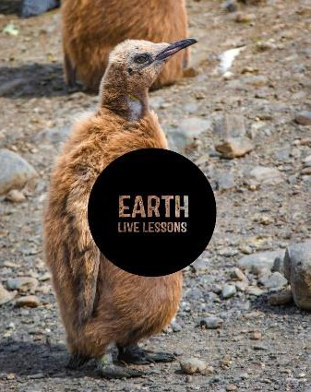
02/04/20
Q3. Name 3 baleen whales
Q4. Name 2 types of tooth whale.
Q5. Can you name one of the most
endangered species of whales?
Video Link: https://www.youtube.com/ watch?v=lGD6-RYgtY8
Doug Allan
Whale encounters Key Stage 3&4

Name:

Hi! Thank you for watching our Earth Live Lessons. I hope you are enjoying them.
Now it is time to show what you know!

Good luck
Lizzie

Q1. A humpback and a blue whale are both types of:
a) Baleen whale b) Toothed whale

Q2. What’s another name for a whale nose?

Humpback whales are known for being aggressive.
True / False

Q5. State 3 NEW things that you have learnt:
1.
2.
3.
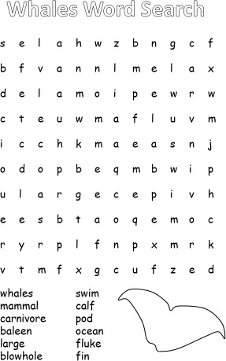
Can you think of ways to conserve the whale population? Write your ideas here.

Follow me on:
@LizzieDalyWildlife @LizzieRDaly
Ask me a question!
Following today’s live lesson do you still have questions you want answered? If so, make sure you send them to Lizzie @LizzieRDaly on Twitter using #EarthLiveLesson #EarthLiveLessons and I’ll try to
answer them! Lizzie
@LizzieDalyWildlifeTV
@LizzieDalyWild

