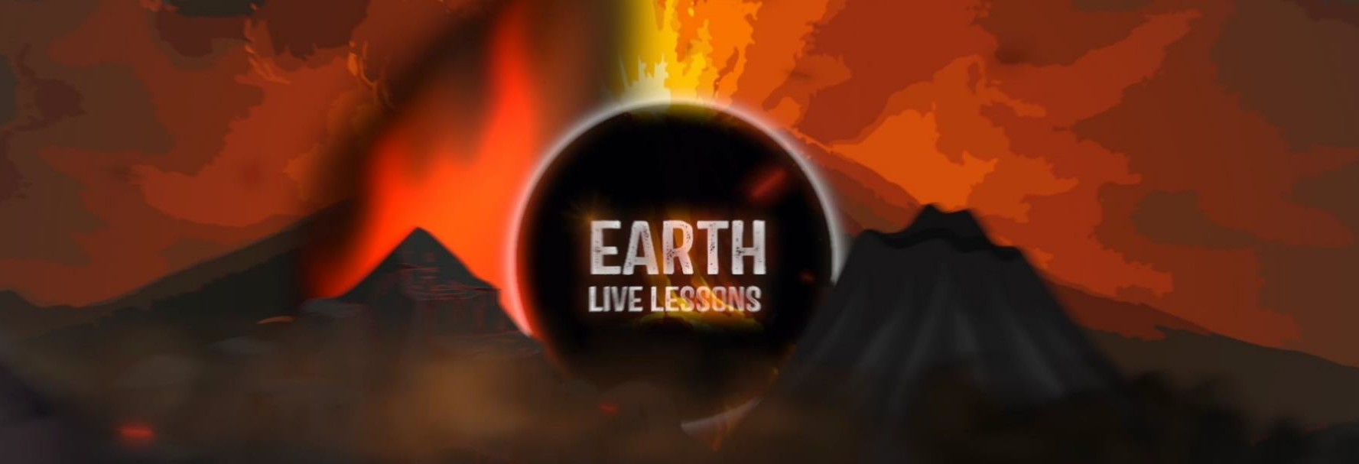
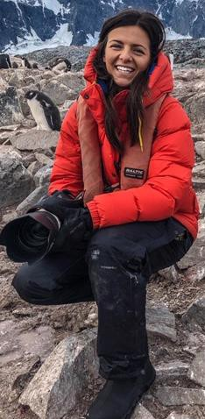
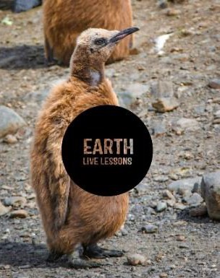
16/04/20
Wes Larson
Stories from a Bear Biologist Key Stage 3&4
Video Link:

https://www.youtube.com/ watch?v=vmlB1kC-t40

Name:

Hi! Thank you for watching our Earth Live Lessons. I hope you are enjoying them.
Now it is time to show what you know! Good
luck
Lizzie

Q1. Name the three species of bear that Wes has been studying

Q2. What is the smallest bear in North America?

Q3. What is the largest species of bear?

_

Page 1
Q3. Name two US National Parks
where you be able to view bears.
Q4. Where in Europe would you find wild bears?

Bears are less likely to attack people who are in tight groups.

True / False

Q5. Visit MISSION WILD and learn more from Wes Larson. Write your notes here.

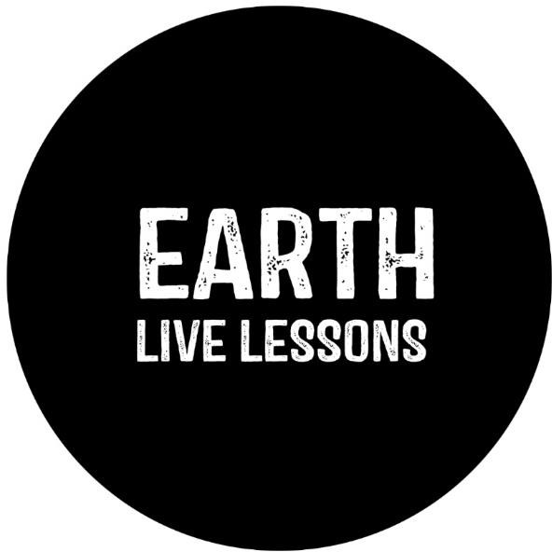

Q6. State 3 NEW things that you have learnt:
1.
2.
3.
Follow me on:
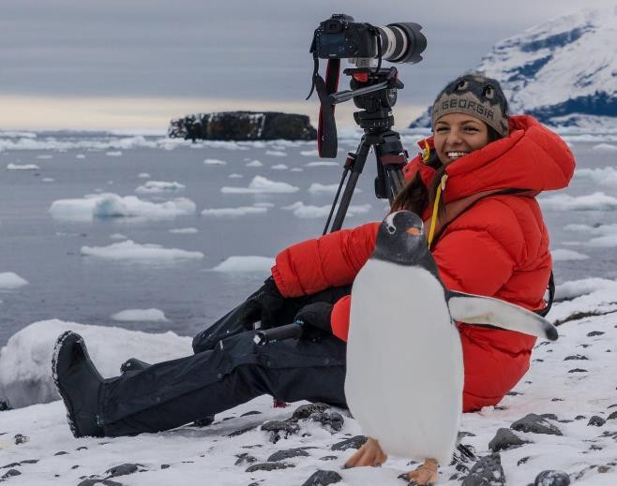
@LizzieDalyWildlife @LizzieRDaly
Ask me a question!
Following today’s live lesson do you still have questions you want answered? If so, make sure you send them to Lizzie @LizzieRDaly on Twitter using #EarthLiveLesson #EarthLiveLessons and I’ll try to
answer them! Lizzie
@LizzieDalyWildlifeTV
@LizzieDalyWild
Page 2

