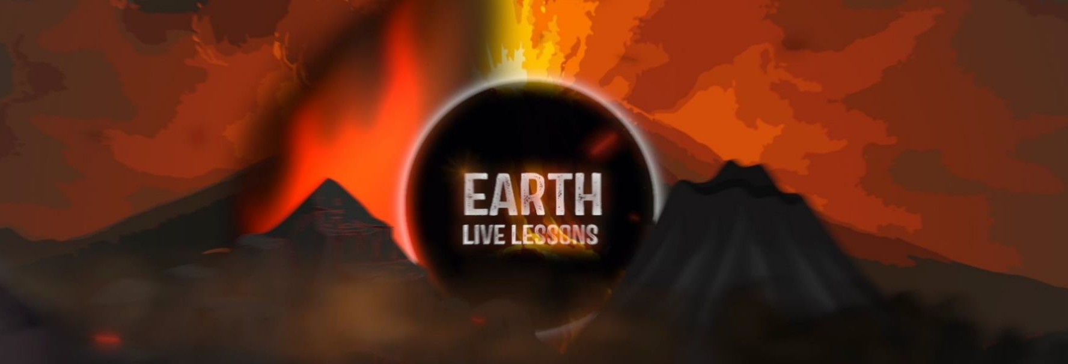
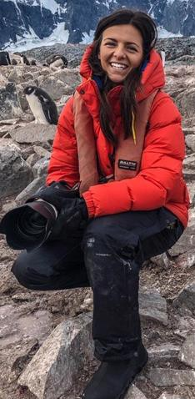
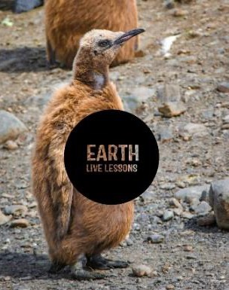
15/04/20
Catherine Gemmell Stop the plastic tide Key Stage 3&4
Video Link:
https://www.youtube.com
/watch?v=s7qC1sMkFVk

Name:
Hi! Thank you for watching our Earth Live Lessons. I hope you are enjoying them.
Now it is time to show what you know! Good luck
Lizzie

Q1. Catherine mentioned a species of dolphin found in the North Sea that is the fattest type of dolphin. What is it? (circle the correct answer)
a) Husky Dolphin b) Spinner Dolphin c) Bottlenose Dolphin

Q2. What type of turtle did Catherine say was as big as her sofa? (circle the correct answer)
a) Hawksbill turtle b) Leatherback turtle c) Green turtle.

Q3. What do turtles mistake plastic
bags for?
Q4. Can you name the 5 items that Catherine said were found in the sea?

Since the government introduced the 5p charge for plastic bags there has been a 25% reduction of plastic bags in marine litter.

True / False
Q5. Click MCS UK and research how you can get involved. Describe here what you may be interested in doing at some point in the future and why?

Q6. State 3 NEW things that you have learnt:
1.
2.
3.

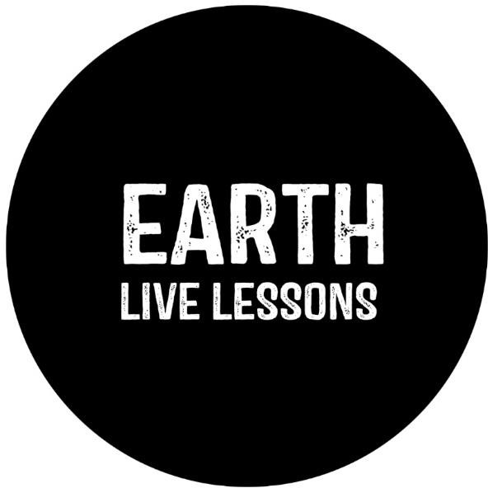
Follow me on:
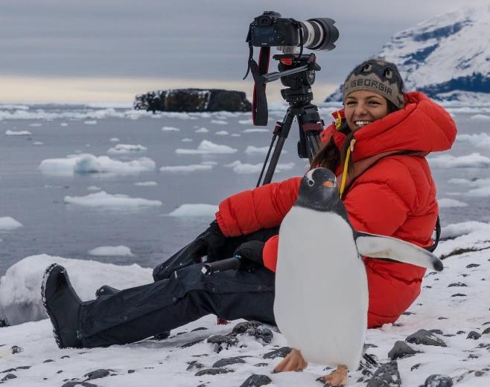
@LizzieDalyWildlife @LizzieRDaly
Ask me a question!
Following today’s live lesson do you still have questions you want answered? If so, make sure you send them to Lizzie @LizzieRDaly on Twitter using #EarthLiveLesson #EarthLiveLessons and I’ll try to
answer them! Lizzie
@LizzieDalyWildlifeTV
@LizzieDalyWild

