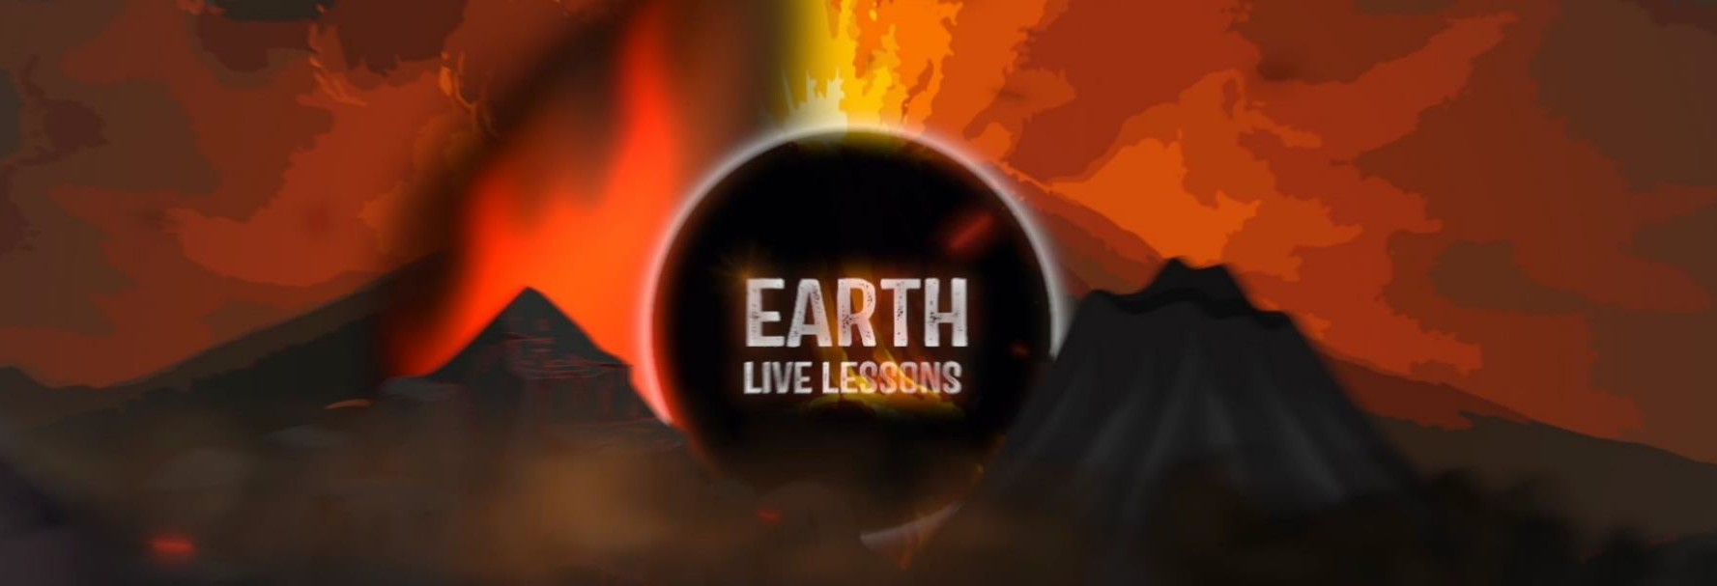
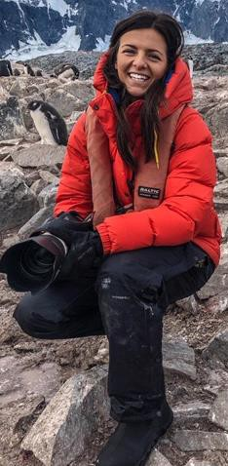
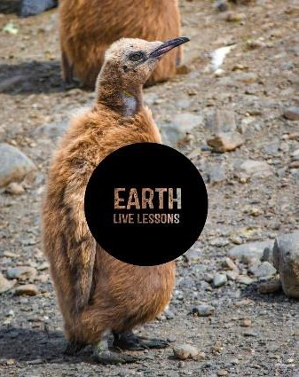
06/04/20
Video Link: https://www.youtube.com/ watch?v=7hRrIyRkmQg
Evie Furness Seagrass success Key Stage 3&4

Name:

Hi! Thank you for watching our Earth Live Lessons. I hope you are enjoying them.
Now it is time to show what you know!
Good luck
Lizzie

Q1. he Seagrass Ocean Rescue projects plans to plant 2 Hectares of seagrass meadow, a Hectare is the size of
a…? (circle the correct answer)
a) Rugby pitch b) Pool Table c) Olympic swimming pool
Q2. What fraction of the world’s oxygen is provided by the oceans?

Q3. List 2 ways in which seagrass
helps climate change
Q4. Can you name 2 animal that help with pollination?
Q5. Approximately how many bags of
soils and seas are being planted?

Oxygen is released through photosynthesis
True / False

Q6. State 3 NEW things that you have learnt:
1.
2.
3.

Q7. What visited Evie and the team when they were collecting seeds
under water? List below.
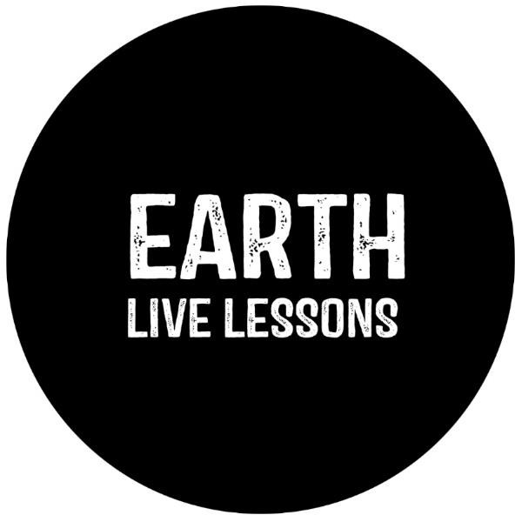

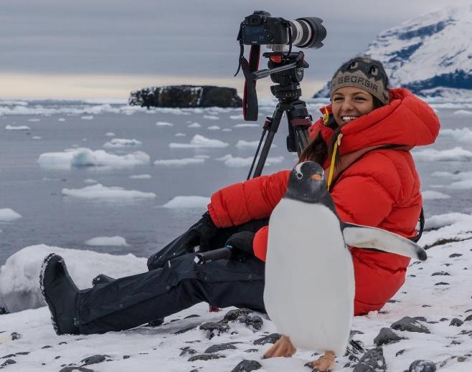
Follow me on:
Ask me a question!
Following today’s live lesson do you still have questions you want answered? If so, make sure you send them to Lizzie @LizzieRDaly on Twitter using #EarthLiveLesson #EarthLiveLessons and I’ll try to
answer them! Lizzie
@LizzieDalyWildlifeTV
@LizzieDalyWild
@LizzieDalyWildlife
@LizzieRDaly

