07/04/20

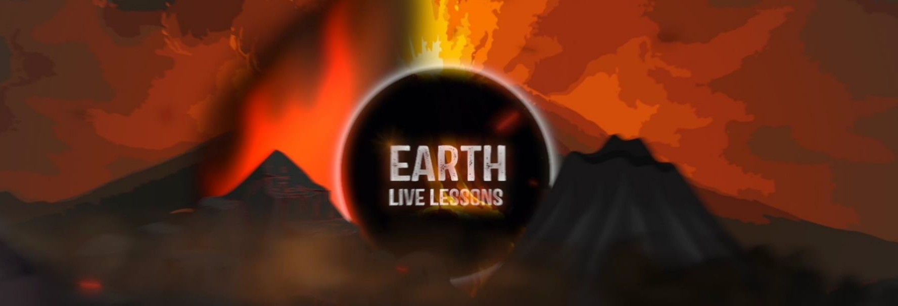

Stephanie Arne Saving Penguins Key Stage 3&4

Video Link: [https://www.youtube.com/](https://www.youtube.com/watch?v=fEblfiSvRYo) [watch?v=fEblfiSvRYo](https://www.youtube.com/watch?v=fEblfiSvRYo)

Name:

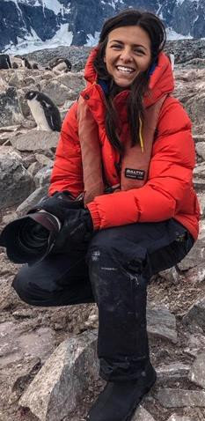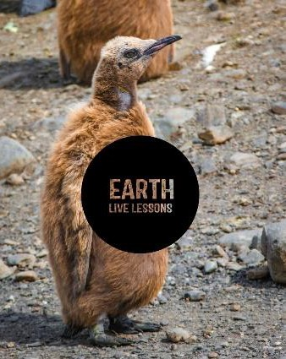

Hi! Thank you for watching our Earth Live

Lessons. I hope you are enjoying them.

Now it is time to show what you know!

Good luck 😊

Lizzie

Q1. Q1. What continent are the penguins from in Stephanie Arne’s live lesson?

a) Africa

b) Asia

c) Antarctica

Q2. What is guano?

Penguins hold their breath when they are underwater

True / False

Page 1



Q3. List 3 reasons why African

penguins are endangered?

Q4. How did Stephanie and her team

help the penguins?

Q5. How many penguin nests are

currently on the island?

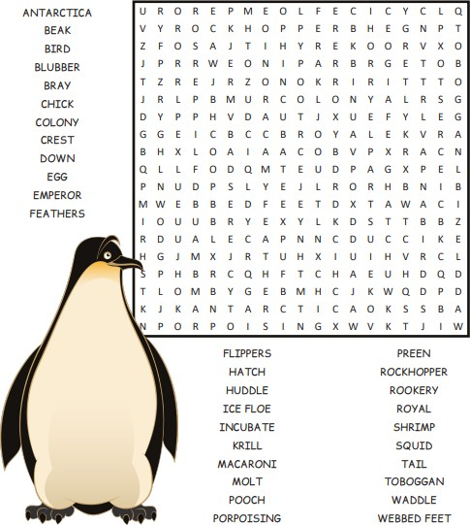

It’s All About the Penguins!

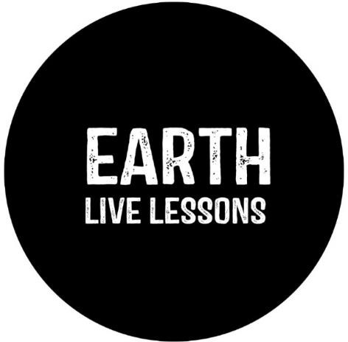

Follow me on:

 @LizzieDalyWildlife @LizzieRDaly

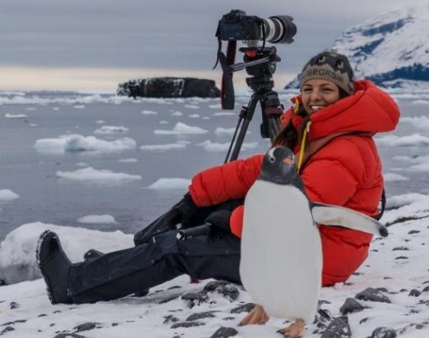

Ask me a question!

Following today’s live lesson do you still have questions you want answered? If so, make sure you send them to Lizzie @LizzieRDaly on Twitter using #EarthLiveLesson

#EarthLiveLessons and I’ll try to answer them! Lizzie

@LizzieDalyWildlifeTV

@LizzieDalyWild

Page 2