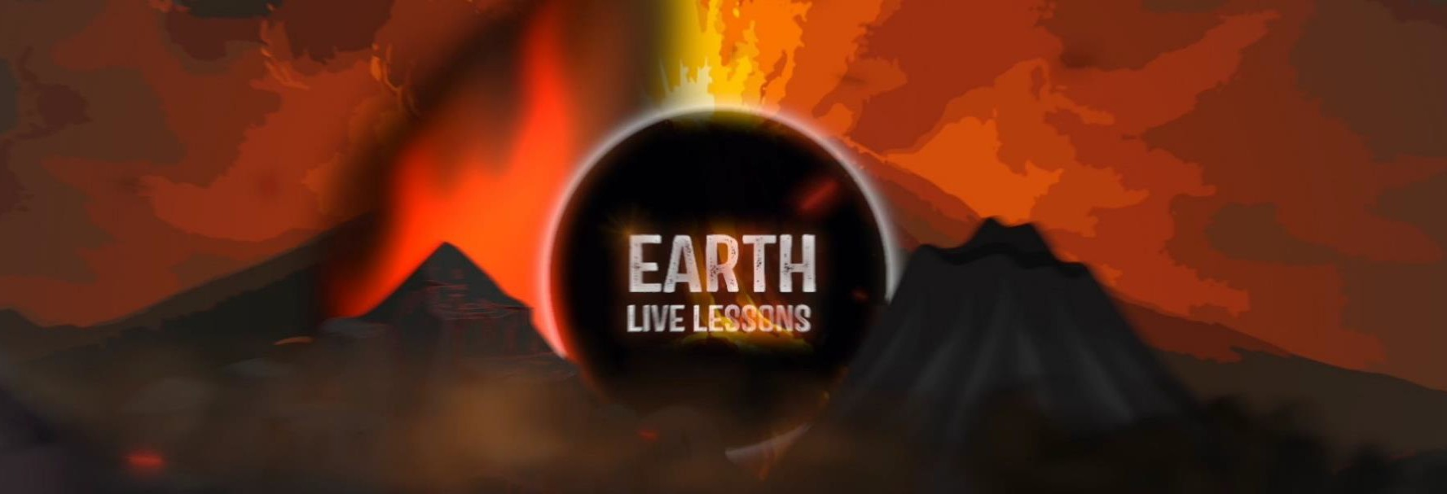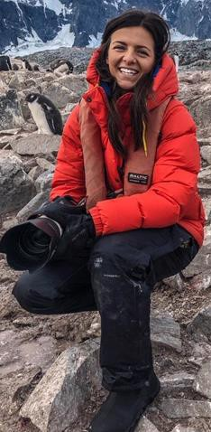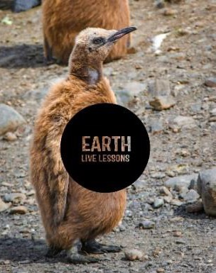

Name:
Video Link:
https://www.youtube.co m/watch?v=nhr9Uz1Sp Jo
21/04/20
Isla Hodgson Swimming with Giants Key Stage 3&4

Hi! Thank you for watching our Earth Live Lessons. I hope you are enjoying them.
Now it is time to show what you know! Good luck
Lizzie

Q1. Basking sharks are the 2nd largest shark species in the world. How big are their fins?
_ _ Q2. How wide is their mouth?
_ _
Q3. What time of year do Basking sharks start to surface around the UK?

Q4. Where does the Gulf stream originate from?

Ocean current transport warm water from Northern latitudes to the equator.

True / False
_ Q5. Basking sharks feed on Zooplankton, but what do Zooplankton feed on?
_ Q6. How many litres of water does a Basking shark filter in an hour?
1) 100,000 2) 500,000 3) 2,500,000
Q7. What word is used to mean that they can jump clean out of the water?

Q8. Where are the three 'hotspots' for Basking sharks where they are seen most in the UK?
_
_
_
Q9. What are the two main threats to Basking Sharks.?
_
_

Visit:https://basking sharkscotland.co.uk
/ to find out more!

Q6. State 3 NEW things that you have learnt:
1.
2.
3.

Follow me on:
@LizzieDalyWildlife @LizzieRDaly
Ask me a question!
Following today’s live lesson do you still have questions you want answered? If so, make sure you send them to Lizzie @LizzieRDaly on Twitter using #EarthLiveLesson #EarthLiveLessons and I’ll try to
answer them! Lizzie
@LizzieDalyWildlifeTV
@LizzieDalyWild

