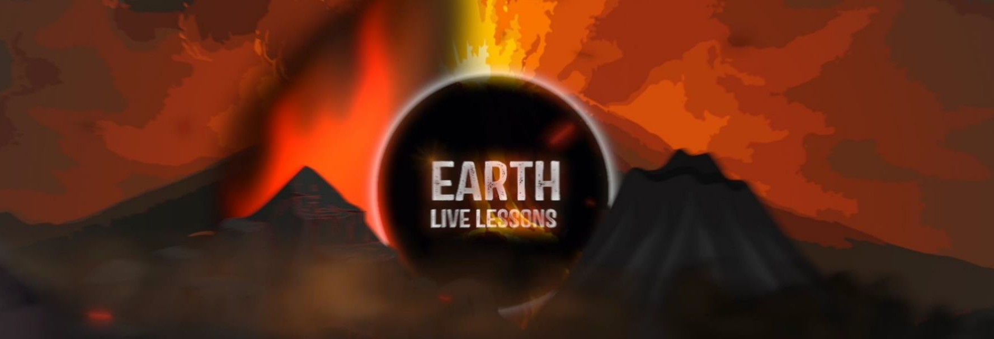
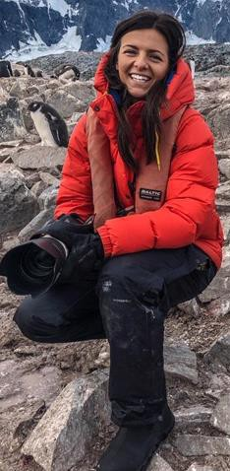
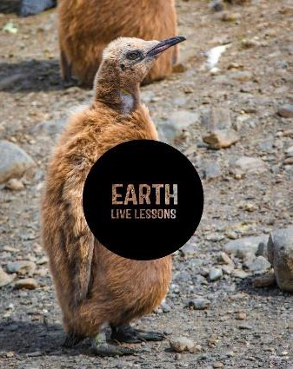
10/04/20
Video Link: https://www.youtube.com/ watch?v=_yVpKsqzDoc
Jamie Coleman Antarctica and Albatross Key Stage 3&4

Name:

Hi! Thank you for watching our Earth Live Lessons. I hope you are enjoying them.
Now it is time to show what you know! Good luck
Lizzie

Q1. How many pairs of puffins can be found in the Farne Islands? (circle the correct answer)
a) 30,000 b) 20,000 c) 5,000
Q2. Where does the Arctic Tern spend the winter?

Q3. List 3 types of tubular nosed
seabirds?.
Q4. What is the primary function of
the tubular nose?
Q5. What is wingspan of a Wandering Albatross?

The Arctic tern weighs less than an iPhone
True / False

Q6. Briefly explain how an albatross can keeps its wings extended with very little effort.

Q5. State 3 NEW things that you have learnt:
1.
2.
3.

Follow me on:
@LizzieDalyWildlife @LizzieRDaly
Ask me a question!
Following today’s live lesson do you still have questions you want answered? If so, make sure you send them to Lizzie @LizzieRDaly on Twitter using #EarthLiveLesson #EarthLiveLessons and I’ll try to
answer them! Lizzie
@LizzieDalyWildlifeTV
@LizzieDalyWild

